
COMP5134 Project
Leave Application System for HR Department

April 10, 2016
Leung KAM Fai
15003558g

Quick Reference Guide
- Software Download

  - This software could be download from below url,
https://github.com/kevinlkf0310/COMP5134_Project.git

- Click “Download ZIP” button to download the source code and jar executable
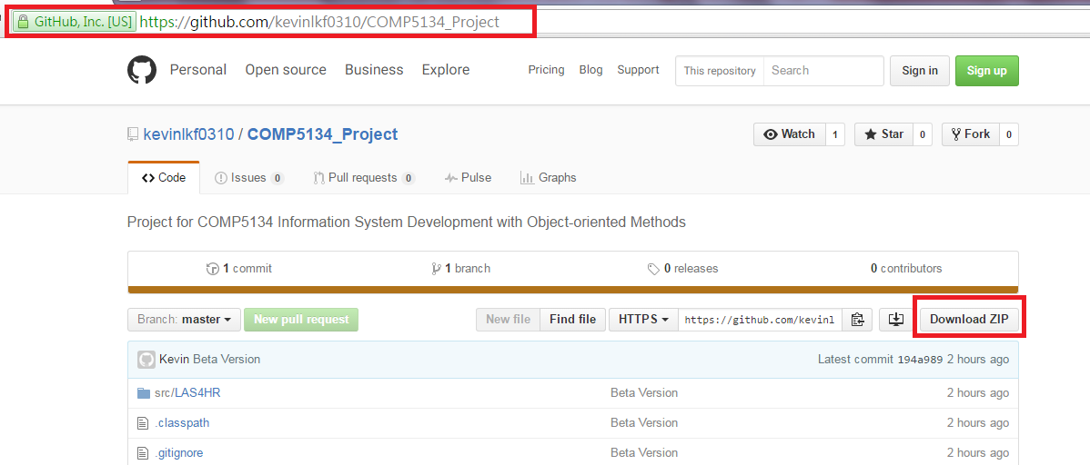

  - After download the file, please unzip it, and you could find below items
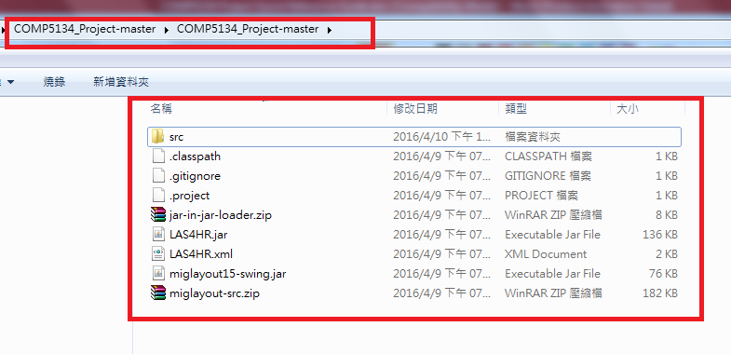

  - Double Click “LAS4HR.jar” to start the application.
*** Please make sure JDK is installed in your machine.
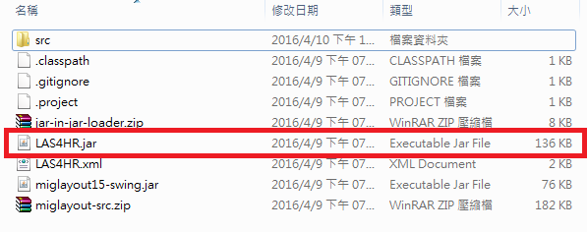

- Function Description
  - System Login, Logout, and exit

- Once the application is startup, click “File” option in menu, and then select the desired function.

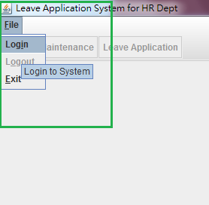

  - System Login

- Input Staff ID and password, then click “Login” button.

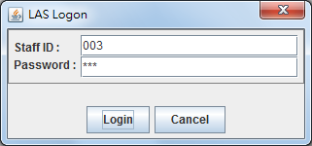

- By default, below users (staff) is created, we can use it at starting point to test the system.
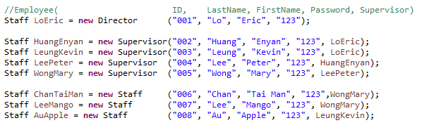

- Once login success, the application title will display your name, and role, the button also will be enabled.
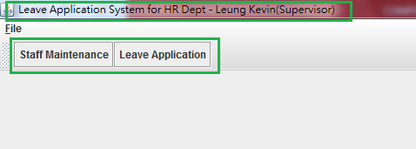

  - Staff Maintenance

- This function could provide the capability to create or modify an existing staff account.
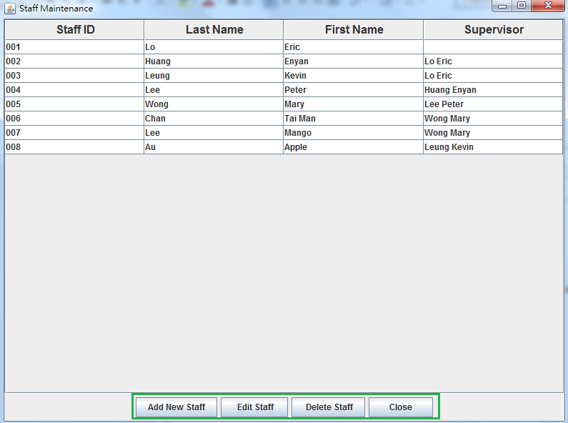

- Click “Add New Staff” button to create a new staff.
- Click “Edit Staff” button to modify the selected staff’s information.
- Click “Delete Staff” button to delete the selected staff.
- Click “Close” button to close and hide this maintenance form.

  - Create Staff

- Input the required information, then click “Save” button

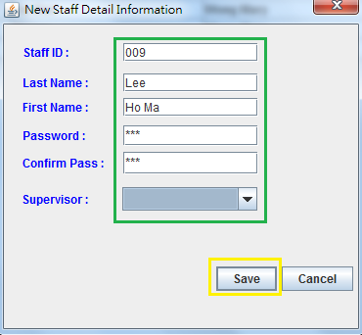

- If no “Supervisor” is selected, this staff will be consider as “Director”

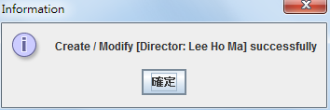

  - Assign Supervisor

- You could assign/change the supervisor for a particular staff at any time by “Modify Staff” function.

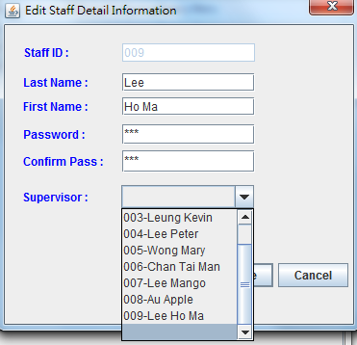

  - Leave Application

- Click “Leave Application” button to apply or handling the leave request for your subordinate(s)

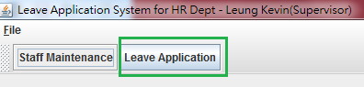

    - Create a new Application

- Click “New Leave Application” button to input the leave application detail information.
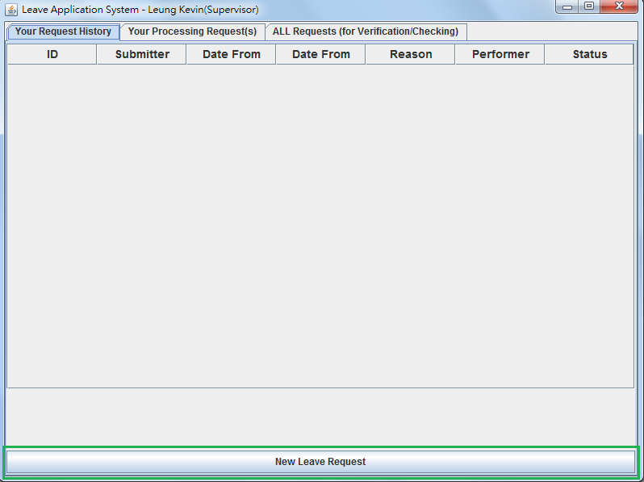

- This function is available for non-director only, this button will became “disable” for director staff login

- Input the leave detail information, then click “OK” button to submit this request

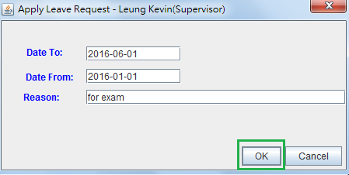

- Afterward, you should receive a popup message from application for submit success.
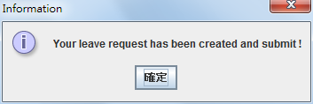
- Then, there is an acknowledge message (with Application ID include) from system regarding to receiving of request, and it is being processing.

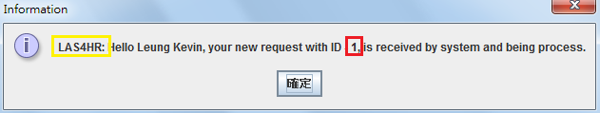

- This application record is now displayed in “Your Request History” tab, it indicates who will be the handler currently, and its status.
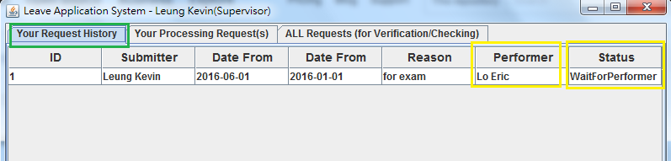

  - Supervisor Notification

- After the requestor submit the request, there is a notification message to their direct (and indirect if any) supervisor for endorse and decline.
- This notification include the name of supervisor (direct or indirect), and request ID

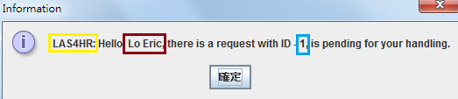

    - Request Handling by Supervisor or Director

- Once the performer (supervisor / director) receive the request, they should login to system, and click “Leave Application” to processing it.

- In “Your Processing Request(s)” tab, it will display the pending request.
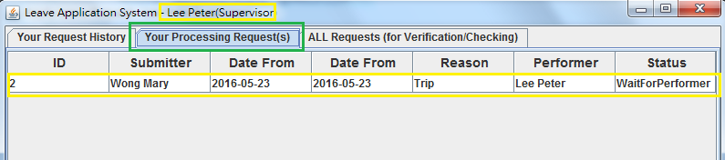
- Select and highlight the request to be processed, and then click “ENDORSE Request” button to endorse the request,
- It will then pass to your supervisor for further endorsement. This loop will be repeated until it is declined by any one further supervisor, or approved by director.

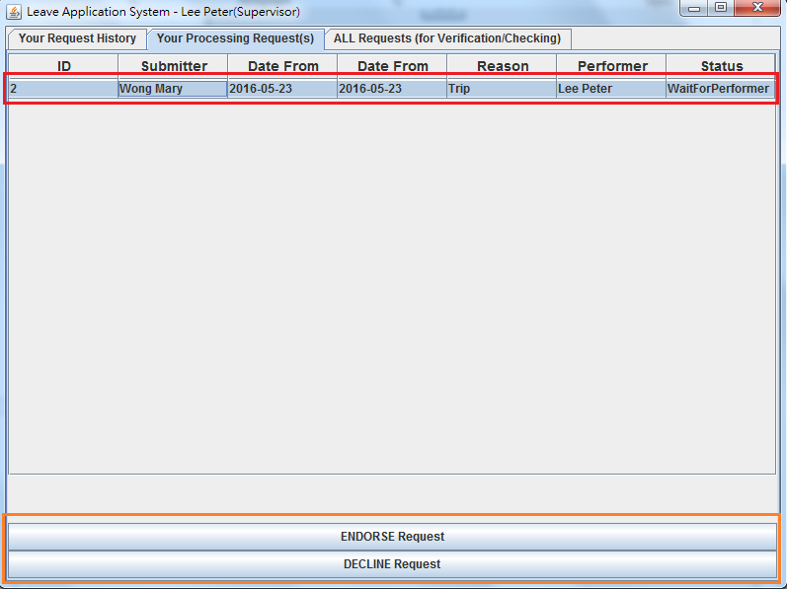

- Click “Yes” button to confirm your “Endorse” or “Decline”

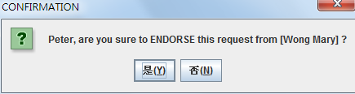

- If a director login to system, the caption of “ENDORSE Requests” button will change to “APPROVE Request”.

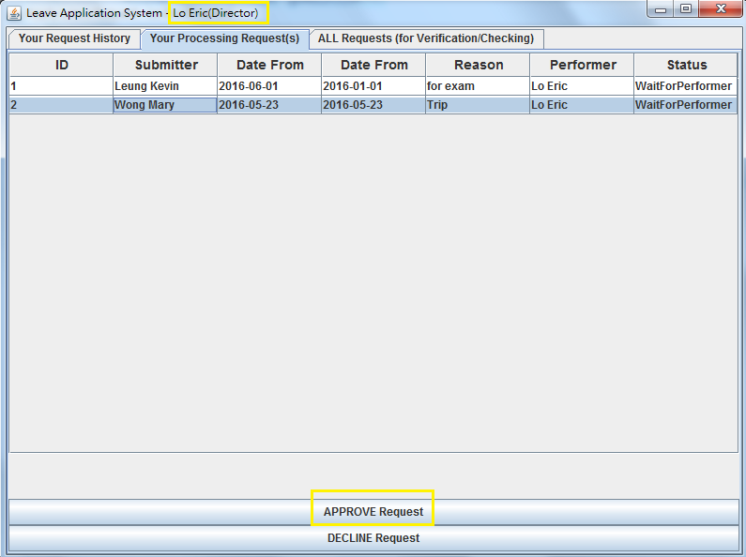

- Click “Yes” button to confirm your “Endorse” or “Decline” action.
- No matter “approve” or “decline”, this request will consider as “completed” after it has been handle by director

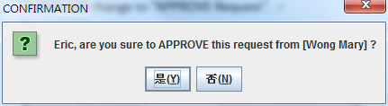

  - Requestor Notification

- After the supervisor / director process the request, requestor will get the notification no matter it is “Approve” or “Decline”.

